|  |  |
| --- | --- |
| Name | Harsh Sharma |
| Roll no. | 19AE30022 |

1. Residuals for 0° angle of attack

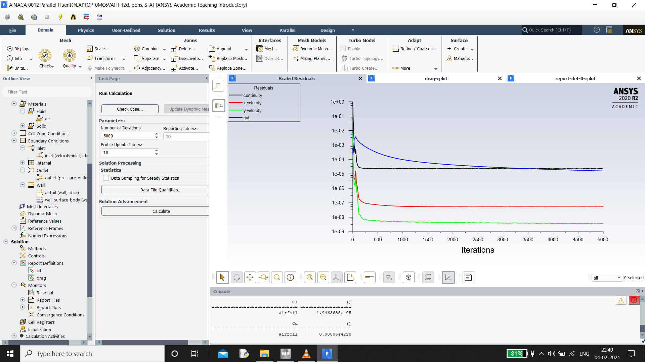

1. Cd for 0° angle of attack

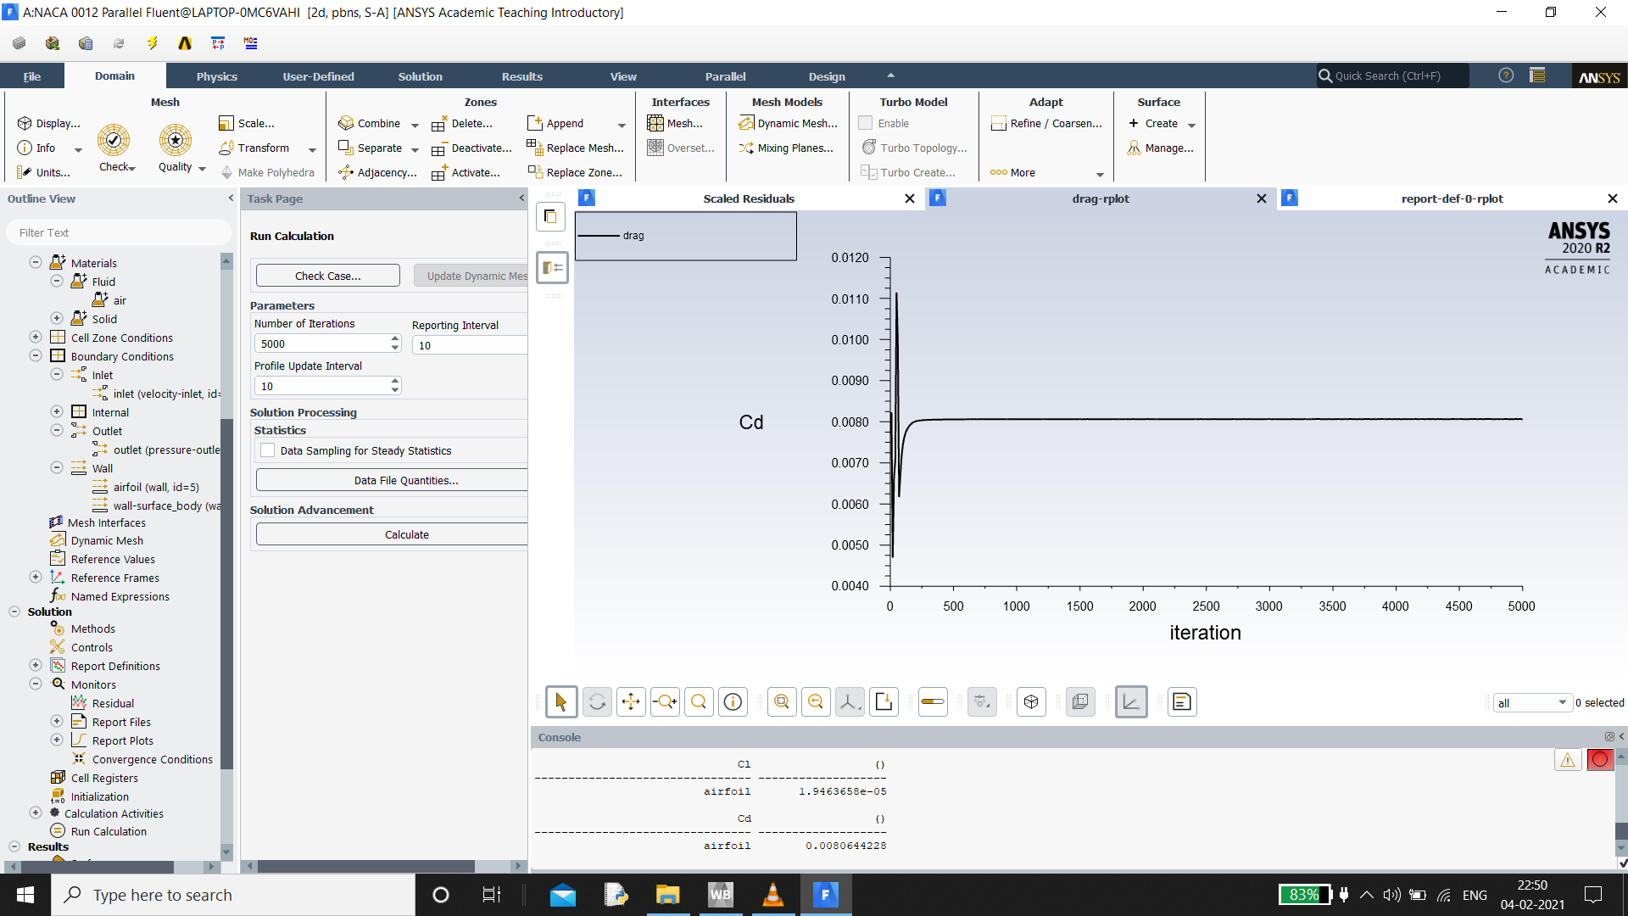

1. Cl for 0° angle of attack

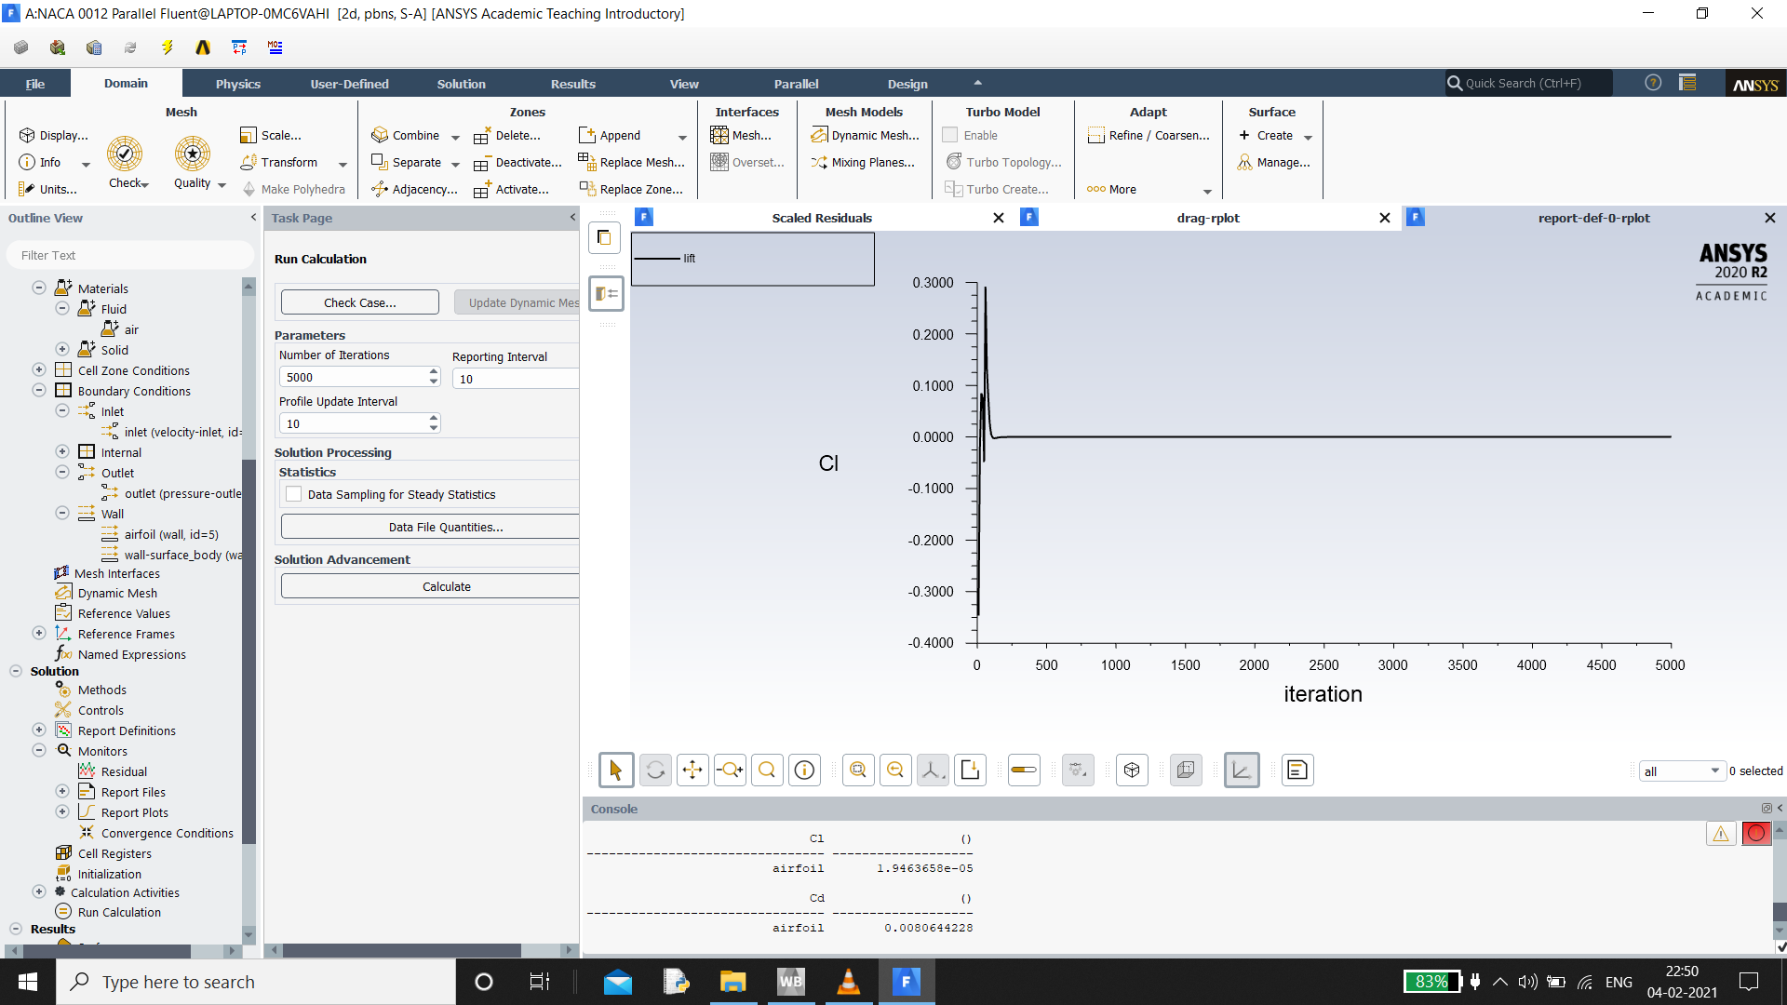

1. Cp distribution for -3° angle of attack

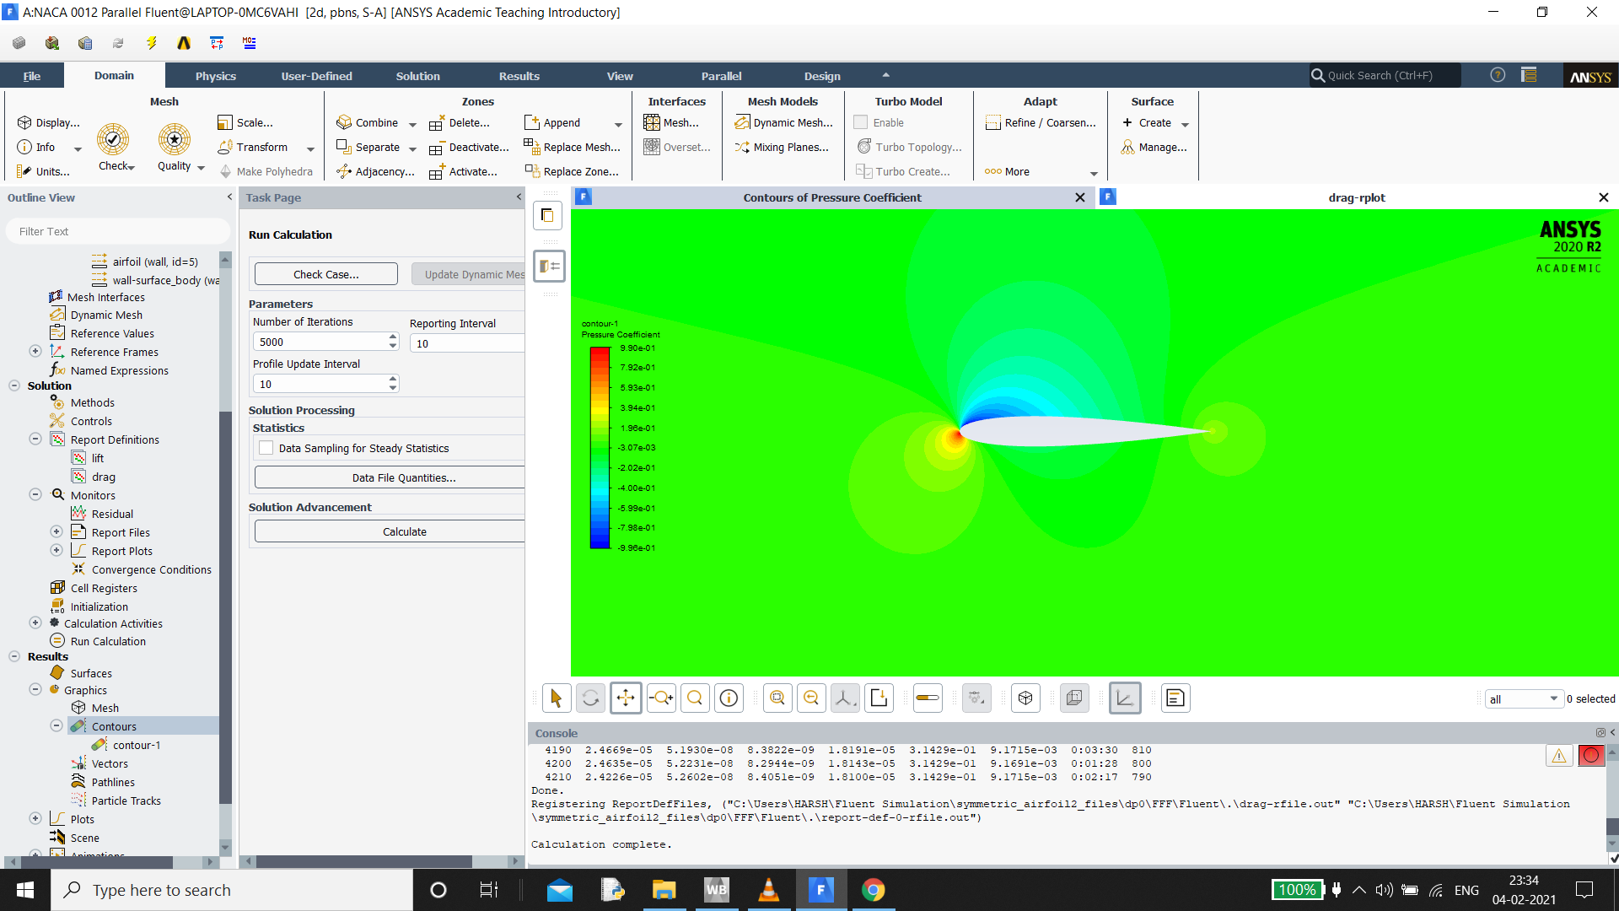

1. Cp distribution for 0° angle of attack

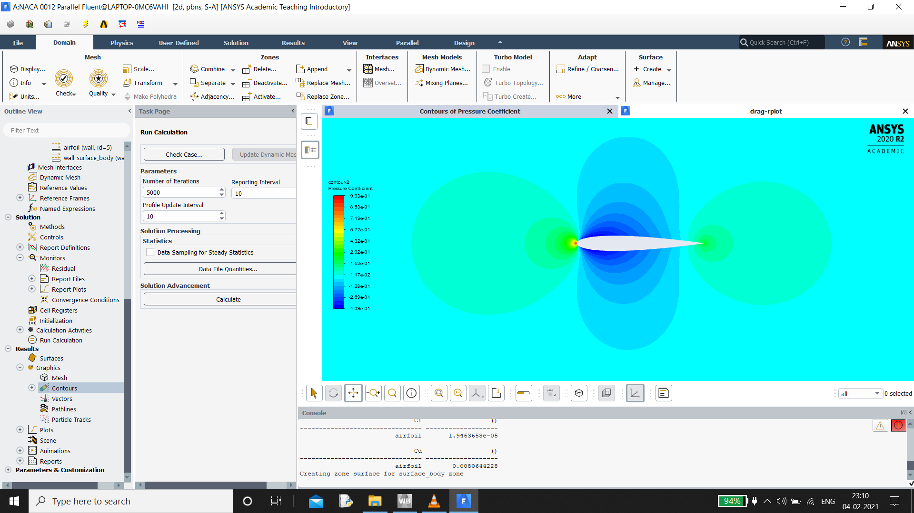

1. Cp distribution for 3° angle of attack

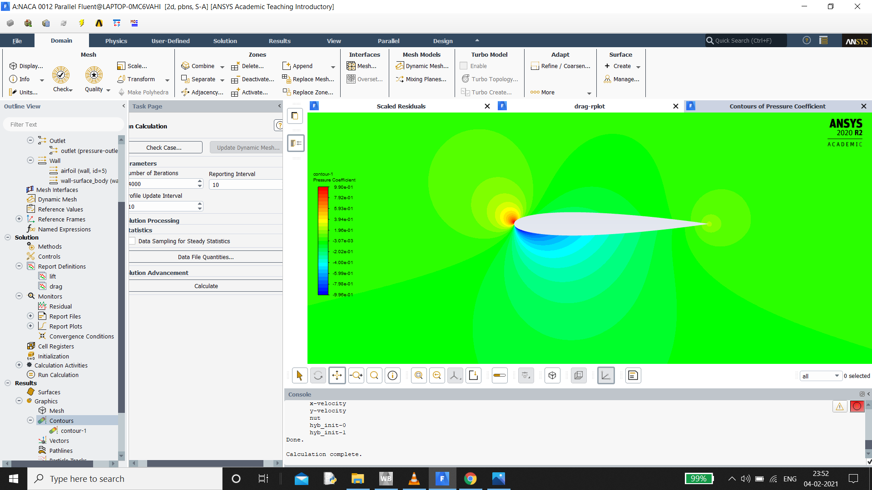

1. Cp distribution for 6° angle of attack

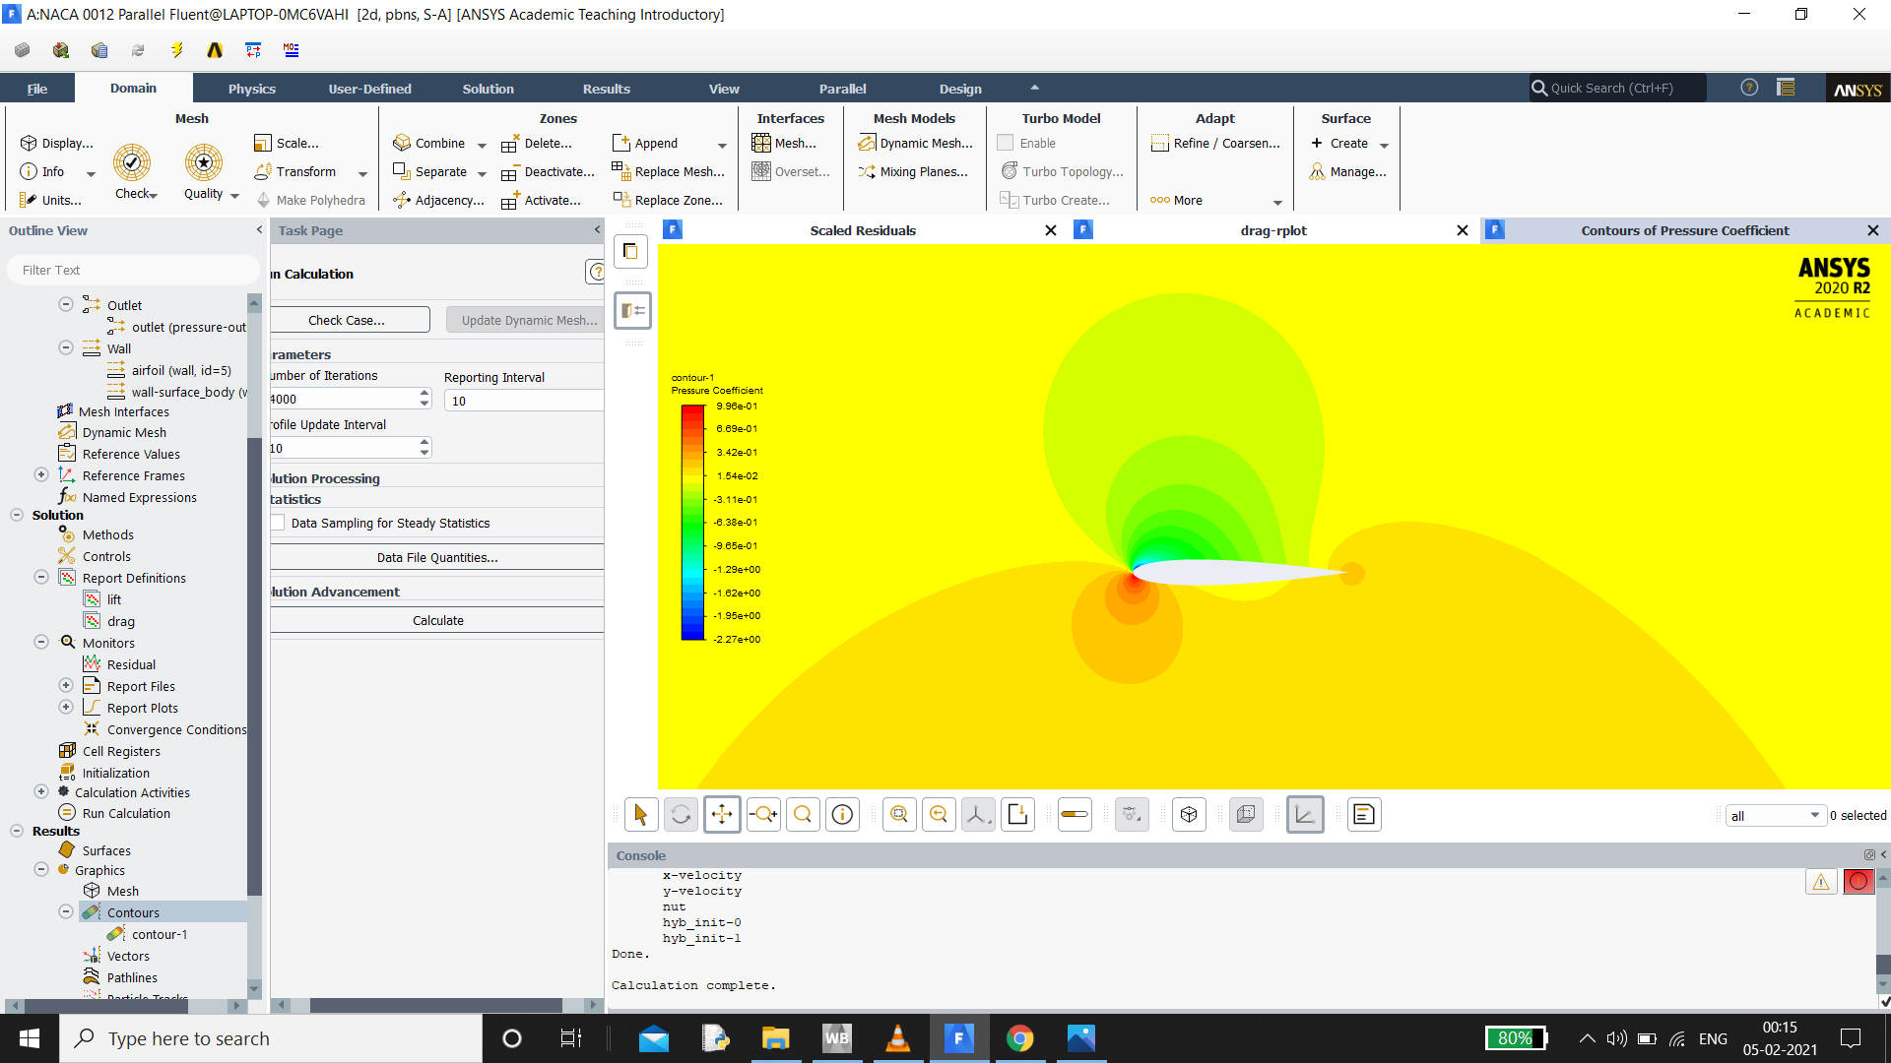

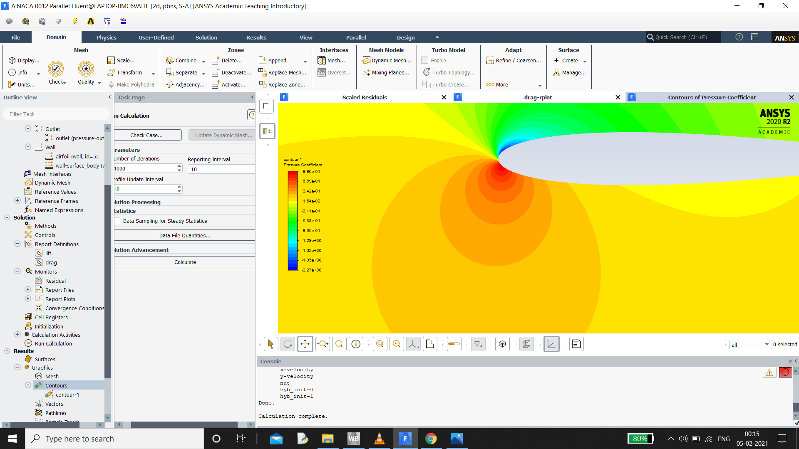

1. Cp distribution for 9° angle of attack

